Erika Hernandez
CS 3705 – Fall 2021
Professor Paulson
Project Status Update

1. Have you selected your project?
Yes I have, So my project was to capture packets from my smart TV. So in my office, I have my computer. But in the background I have to have a TV playing. The TV is connected to my WiFi and I can stream videos and such.

2. Are you on track to finish the project by the due date?
I hope so.

3. Have you run into any obstacles that you need help with?
Yes I have, So I was able to pick my TV IP address with Wireshark. The issue I'm running into is that is saying Protocol SSDP, shouldn't it TCP? Anyways, when I look at the Server it says Roku which is in the TV. But it wont give me much more information than that. So I then I found my Apple TV IP address and I wanted to see if it would do the same thing. It does, I would only see that my Apple TV is getting traffic sent back and fourth. But what its sending? I would get no information at all.
So I doesn’t really give me much information about the packages themselves. So what I need to figure out, is how to take of the outer layer and get underneath the packages themselves. I mean is that even a possible? I spend a whole day trying to get this far. So perfect timing how you asked about this.

My next steps are to figure out if its even possible to go further into the packets and see if I can get the actual traffic that my TV Hisense that has Roku as I click on Amazon prime to watch a movie. Basically be the man in the middle of the traffic from the internet and the device its self.
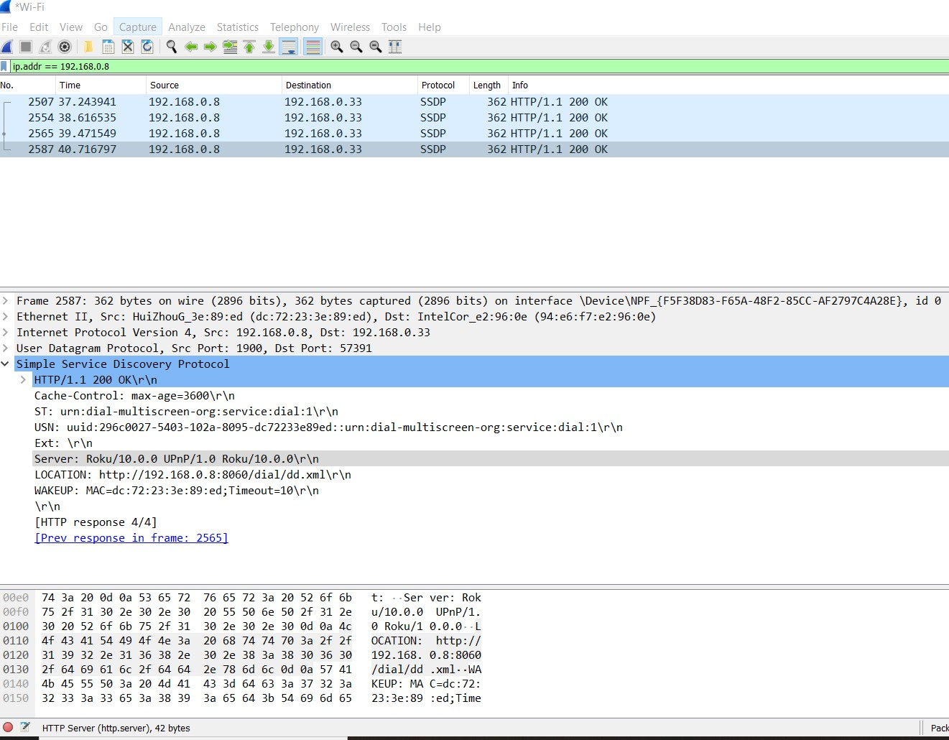Figure 1: WiFi capture of my TV IP address

